1. How many types of conditions are available in conditional formatting on Excel?

There are 5 types of conditional formatting visualizations available:

* Background Color Shading (of cells)
* Foreground Color Shading (of fonts)
* Data Bars
* Icons (which have 4 different image types)
* Values.

1. How to insert border in Excel with Format Cells dialog?

* Click Home > the Borders arrow.
* Pick Draw Borders for outer borders or Draw Border Grid for gridlines.
* Click the Borders arrow > Line Color arrow, and then pick a color.
* Click the Borders arrow > Line Style arrow, and then pick a line style.
* Select cells you want to draw borders around.

1. How to Format Numbers as Currency in Excel?

To quickly apply the Currency format, **select the cell or range of cells that you want to format, and then press Ctrl+Shift+$**. Like the Currency format, the Accounting format is used for monetary values. But, this format aligns the currency symbols and decimal points of numbers in a column.

1. What are the steps to format numbers in Excel with the Percent style?

* To quickly apply percentage formatting to selected cells, click **Percent Style** Button image in the **Number** group on the **Home** tab, or press **Ctrl+Shift+%**. If you want more control over the format, or you want to change other aspects of formatting for your selection, you can follow these steps.
* On the **Home** tab, in the **Number** group, click the icon next to **Number** to display the **Format Cells** dialog box.
* 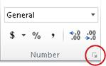
* In the**Format Cells** dialog box, in the **Category** list, click **Percentage**.
* 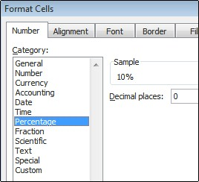
* In the **Decimal places** box, enter the number of decimal places that you want to display. For example, if you want to see **10%** instead of **10.00%**, enter **0** in the **Decimal places** box.

1. What is a shortcut to merge two or more cells in excel?

* Ctrl + M - This shortcut key will merge the selected cells into one cell.
* Ctrl + Shift + M - This shortcut key will merge the selected cells into one cell, and keep the data in the upper-leftmost cell.

1. How do you use text commands in Excel?

**Select the column, or range where you'll be putting the values, then use CTRL+1 to bring up the Format > Cells dialog and on the Number tab select Text**. Now Excel will keep your leading 0's. If you've already entered data and Excel has removed your leading 0's, you can use the TEXT function to add them back.